**Mini Project Report On**

**Flower recognition System and Classification Using CNN**

Submitted in partial fulfilment of the requirement for the award of the degree of

**BACHELOR OF TECHNOLOGY**

**IN**

**COMPUTER SCIENCE & ENGINEERING**

### Submitted by:

Student Name University Roll No

Aarchi 2022012

***Under the Mentorship of***

**Mr Sanjay Roka**

**Department of Computer Science and Engineering**

**Graphic Era (Deemed to be University)**

**Dehradun, Uttarakhand**

**July-2024**



**CANDIDATE’S DECLARATION**

I hereby certify that the work which is being presented in the project report entitled **“Flower Recognition and Classification** **Using Convolutional Neural Network”** in partial fulfilment of the requirements for the award of the Degree of Bachelor of Technology in Computer Science and Engineeringof the Graphic Era (Deemed to be University), Dehradun shall be carried out by the under the mentorship of **Mr Sanjay Roka,** Department of Computer Science and Engineering, Graphic Era (Deemed to be University), Dehradun.

Name : Aarchi

University Roll no: 2022012

Table of Contents

|  |  |  |  |  |  |
| --- | --- | --- | --- | --- | --- |
| **Chapter No.** |  |  |  | **Description** | **Page No.** |
| Chapter 1 |  |  |  | Introduction | 4-5 |
| Chapter 2 |  |  |  | Literature Survey | 6 |
| Chapter 3 |  |  |  | Methodology | 7 - 13 |
| Chapter 4 |  |  |  | Result and Discussion | 14 – 15 |
| Chapter 5 |  |  |  | Conclusion and Future Work | 16 - 17 |
|  |  |  |  | References | 18 |

**Chapter 1**

**Introduction**

In our everyday lives, we experience various trees and plants in our environment. Each plant or tree has it possess interesting characteristics, and numerous of them deliver particular sorts of natural products or blossoms. These unmistakable highlights make it conceivable for us to recognize diverse species. For occurrence, apple trees are known for their apples, whereas cherry bloom trees are celebrated for their excellent blossoms.  
Blossoms plays a major part in distinguishing the plants. Each plant has its claim bloom. No two diverse plants have the same sort of bloom. They come in different shapes, sizes, and collars, each related with a particular sort of plant or tree. For case, the dynamic yellow blossoms of sunflowers or the fragile pink petals of cherry blooms are unmistakable. By watching these blooms, we are able effortlessly recognize one plant from another.  
There are so numerous distinctive sorts of blossom species in this world. Amid the childhood we utilize to memorize a few of them in school days. Such as rose, sunflower, marigold, lily, jasmine etc. Presently these are as it were few species which we utilize to memorize in childhood. What in the event that you watched a blossom and you do not know the title of that bloom. In that circumstance on the off chance that we are have a application which take a picture of that bloom as a input and gives the title and points of interest of that blossom at that point it'll be more simple to investigate each bloom in a nitty gritty way.  
Envision on the off chance that you went to a bloom cultivate where there are different sorts of bloom. Presently in case you found a bloom which you had ever seen. Presently do not know the title of that bloom but you need to urge information of that blossom. In that case envision in the event that we are having a mobile and took a picture of that blossom and after that transferred in this application. At that point we are going get all points of interest around that bloom.  
Blossom acknowledgment is an curiously utilize of computer vision, which could be a innovation that makes a difference computers get it pictures. This includes distinguishing distinctive sorts of blooms from their pictures. This innovation can be used in numerous areas, such as considering plants, cultivating, cultivating, and instructive apps. Convolutional Neural Systems (CNNs) are a effective apparatus for recognizing pictures, making them a extraordinary choice for making a framework that can naturally recognize blossoms. Blooms come in numerous distinctive shapes, sizes, and collars , which makes it difficult for individuals to distinguish them, particularly in case they are not specialists.

**1. Differing qualities and Significance of Blossoms:**  
Blossoms are assorted in their characteristics like shape, colour, and scent. They play crucial biological parts by giving food and protect for different creature species. **2. Social and Financial Centrality:**  
Blooms are socially noteworthy and have financial significance in segments like enhancement, pharmaceutical, and nourishment and refreshments.  
**3. Programmed Blossom Acknowledgment:**  
This includes utilizing computer vision methods, particularly CNNs, to distinguish and categorize diverse species of blossoms based on advanced pictures.  
**4. Convolutional Neural Systems (CNNs):**CNNs are profoundly compelling for picture acknowledgment assignments due to their capacity to memorize various levelled highlights straightforwardly from pixel values.  
**5. Usage in Keras:**  
Karas, a machine learning library, is utilized for developing and preparing CNN models. It rearranges the method of building fake neural systems.  
 There are two main groups of techniques that have been developed for image classification:

1. **Traditional Methods**: These techniques typically involve extracting handcrafted features from flower images, such as colour histograms, texture descriptors, and shape characteristics. These features are then used as input to machine learning algorithms like Support Vector Machines (SVMs), Random Forests, or k-Nearest Neighbours (k-NN) classifiers.
2. **Deep Learning Methods**: Deep learning has revolutionized flower classification by automatically learning hierarchical representations of data. Convolutional Neural Networks (CNNs) are especially powerful in this context, as they can directly learn meaningful features from raw pixel data. CNNs are trained on large datasets.

Both methods have their strengths. Traditional methods are simpler but need humans to define what to look for. Deep learning is more complex but can learn by itself from lots of pictures, making it very accurate.

**Chapter 2**

**Literature Survey**

A literature survey on Flower Recognition and Classification model would involve reviewing relevant studies, research papers, and articles that focus on predicting flower images using various methodologies and techniques. Below is a brief overview of some key themes and approaches found in the literature

1. Mastura Hanafiah, Sofianita Mutalib (2022) This project has been made with the more advanced techniques used in machine learning concepts like transfer learning approach and they have checked the performance through image classification model like AlexNet and VGC16.
2. M V.D Prasad, P Rajesh Kumar, A Hari Chandana (2017) They have used the different CNN architecture were designed and tested with our flower image data to obtain better accuracy in recognition and various pooling schemes has also been implemented to improve the classification,
3. Nilsback and Zisserman (2008) contributed to the field with the development of the Oxford 102 Flower Dataset, a large collection of flower images used to benchmark classification algorithms. Their study showcased automated flower classification across a significant number of classes, driving further research in the domain.
4. Krizhevsky, Sutskever, and Hinton (2012) illustrated the control of exchange learning in their point of interest work on ImageNet Classification with Profound Convolutional Neural Systems (AlexNet). They appeared that pre-trained models may well be fine-tuned for particular assignments like blossom classification, accomplishing tall exactness with diminished preparing time
5. Liangji Zhou, Qingwu L (2017) these are from the Hoai University as for image classification task they have used the traditional CNN models of the softmax function. They have resolved the shortcoming by using CNN and they have solved this problem by Biometric pattern recognition.

**Chapter 3**

**Methodology**

This project is built by using CNN [Convolutional Neural Network] also known a convnet the model which lies under the deep learning which is the subset of Machine learning in which is known for grid like topology like time series data(1D) or images(3D) So basically, we have used the several methods of CNN model to get the expected and accurate results.

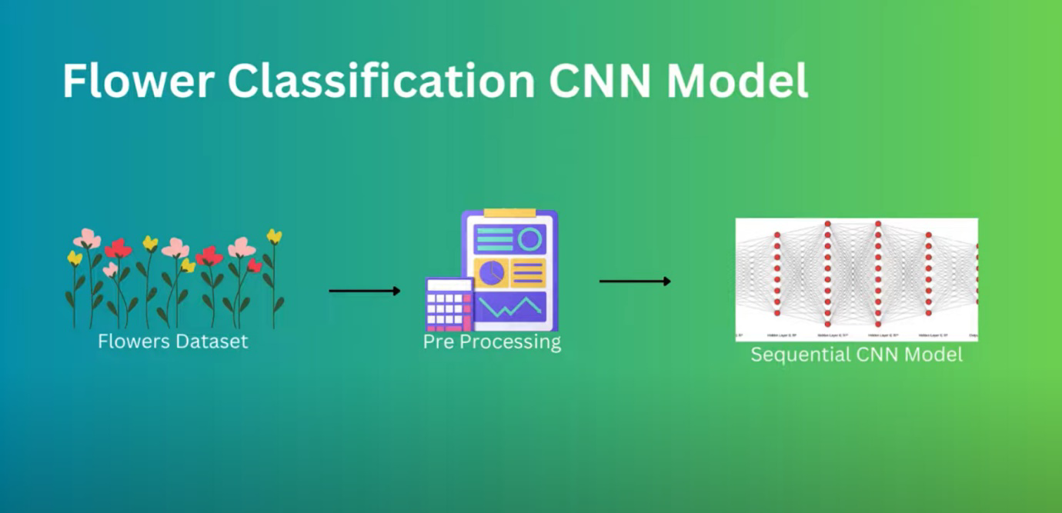

**3.1 All about CNN’s:** It is used for the task like image recognition and the task like pixel data processing although there are different kind of neural network in deep learning CNNs are the preferred neural architect for identifying object therefore it is suitable for where accurate results are crucial. CNNs are outlined to imitate the human visual framework, highlighting different layers of convolutional channels that extricate important highlights from the input picture. These extricated highlights are at that point utilized to classify and distinguish distinctive sorts of blossoms, making CNNs well-suited for errands like recognizing and categorizing different bloom species from pictures.

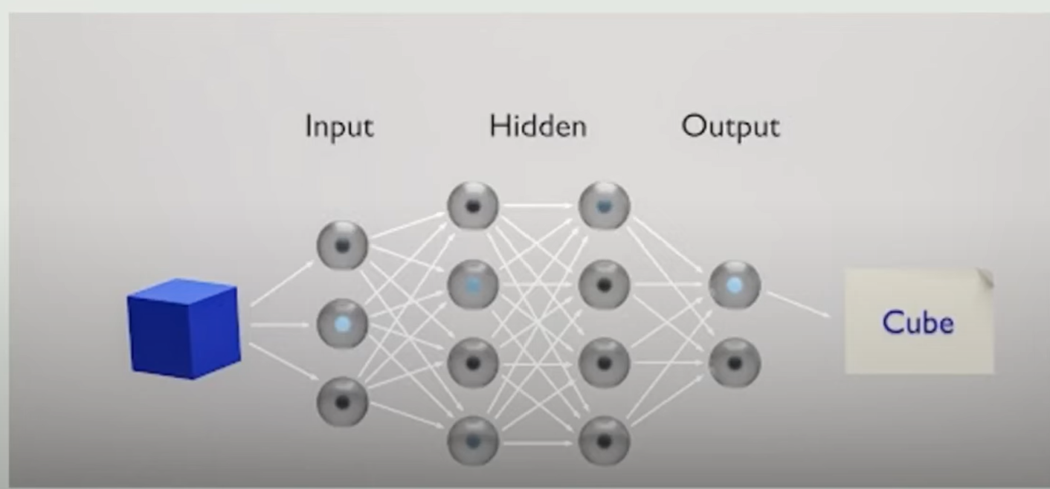

**Fig 1: Basic layers in CNN**

These are the hidden layers first it act on primitive features that is edges and then it act on further more layers

**3.2 How Does CNN Works?**

CNN is like a little compute framework that looks at pictures and figures out what's in them. It comprises of numerous layers of interconnected neurons that conduct scientific operations on input information. Fundamentally, it has numerous layers of associated parts, kind of like perplex. At each layer, these operations are outlined to recognize progressively complex highlights of the input picture. So here each layer makes a difference the computer get it distinctive things within the picture, beginning from the basic stuff and getting more complex. The ultimate layer produces a set of outputs that can be translated as the likelihood of a specific question or include being show within the input picture. It performs the convolutional operation and for that we need filters or kernels which detect the edges which is the primitive step but in deep learning we do not need to set those filters manually this can be done by automatically by using back propagation which decide itself and set it randomly.

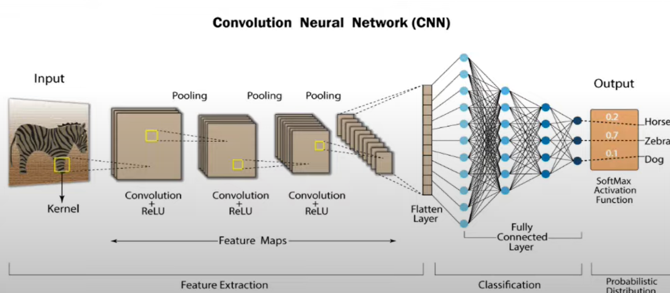

**Fig 2: CNN Model Architecture**

Now let’s see the process or we can say method of implementing this CNN network

**1.Problem Statement:**

To identify different types of flowers in the given or provided images and to show whether the given image contains a particular flower type or not.

**2. Data Collection:**

I took my dataset called “flowers-recognition” from the input directory the Kaggle platform. In this dataset there are five folders. First folder is named as ‘Daisy’, second folder is named as ‘Dandelion’, third folder as ‘Rose’, forth folder as ‘Sunflower’ and fifth folder as ‘Tulip’. Now these five folders are having images of flowers according to their folder names. For example, a folder named Rose is containing the images of Rose Flowers only similarly other folder are having the images of their respective folder names. So, by using these images we can train our model and we will test our model by using the provided MR images.

1. **Importing necessary libraries:**

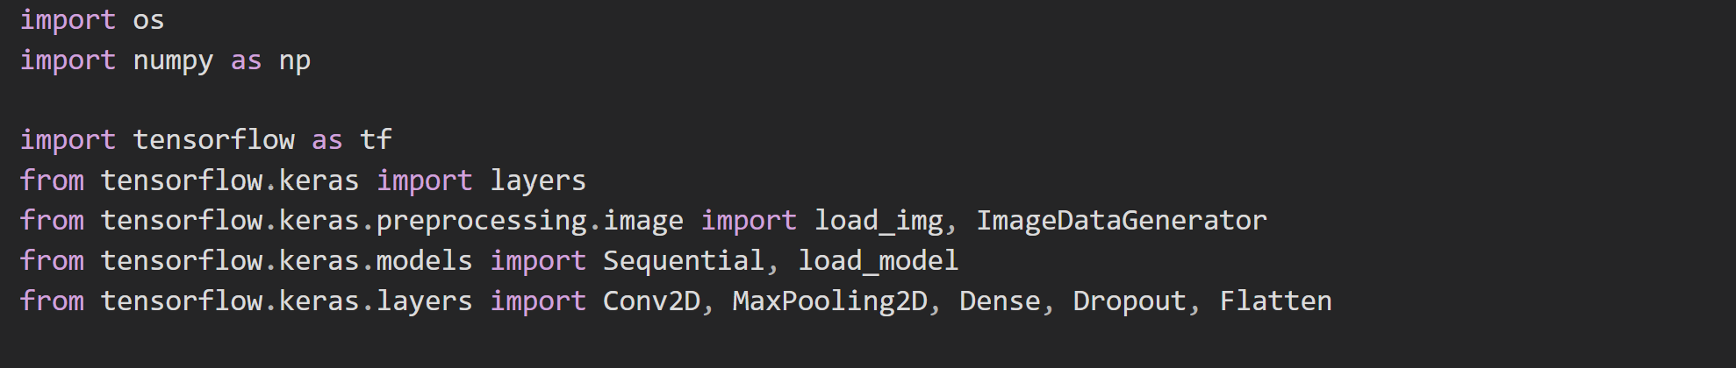

**3. Data Preprocessing:**

After importing all the images using pandas lib, now we make a list of Each folder using ‘os.listdir()’ function. Then we will convert all the images to a list so that we can count total number of flower images present in each folder. And then we will make them print. It will provide the count of Total flowers present in dataset. As shown in fig [3.1] we wrote a code to count and print the total number of flower images. So now these are stored in the folders as a file now will load this by using NumPy array so it will load the image in to array as a dataset.

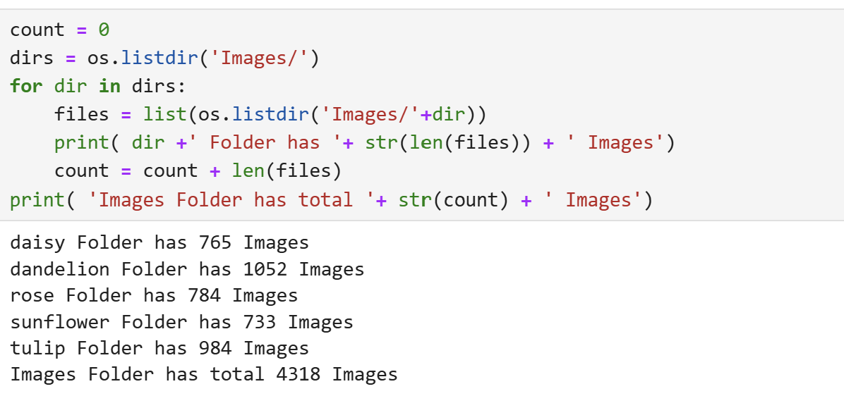

**Fig 3.1: listing out the directories of files**

**3.Data Splitting:**

Now we will split the data into two categories. Firstly for training which is named as ‘training dataset’ and second is for validation which is named as ‘validation dataset’. As shown in the figure [3.2]. 80 percent of the data goes to training dataset and rest 20 percent goes to validation dataset in validation set it indirectly using the training dataset set the utmost accuracy by defining the cross validation on the training dataset then take the mean of all the accuracy it gave. All the data is fitted in to the cache memory as it also not has the so much data so all the data will be stored in the cache memory

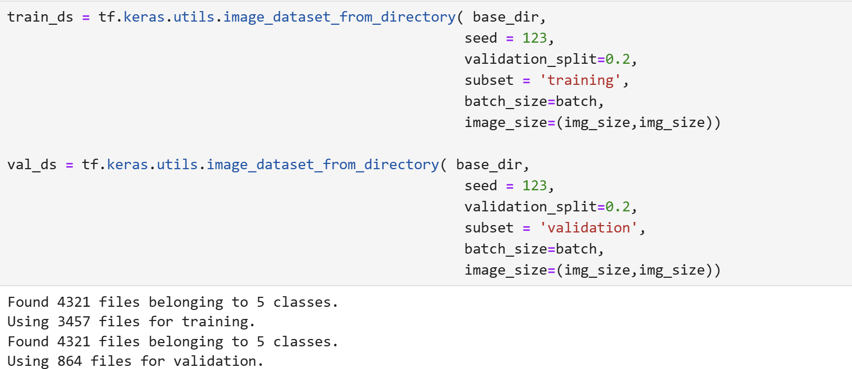

**Fig 3.2: Distributing the Dataset Into Training Dataset**

**4.Data Augmentation**

As we have only 4317 images in our dataset which is a very less dataset usually, we use to take the data in the TB and GB so. Data augmentation is a technique used to increase the diversity of your training data without actually collecting new data. It involves applying random transformations to the existing data, such as rotations, flips, zooms, translations, and changes in brightness, to create new, modified versions of the data. This process helps improve the generalization ability of machine learning models, particularly in avoiding overfitting.

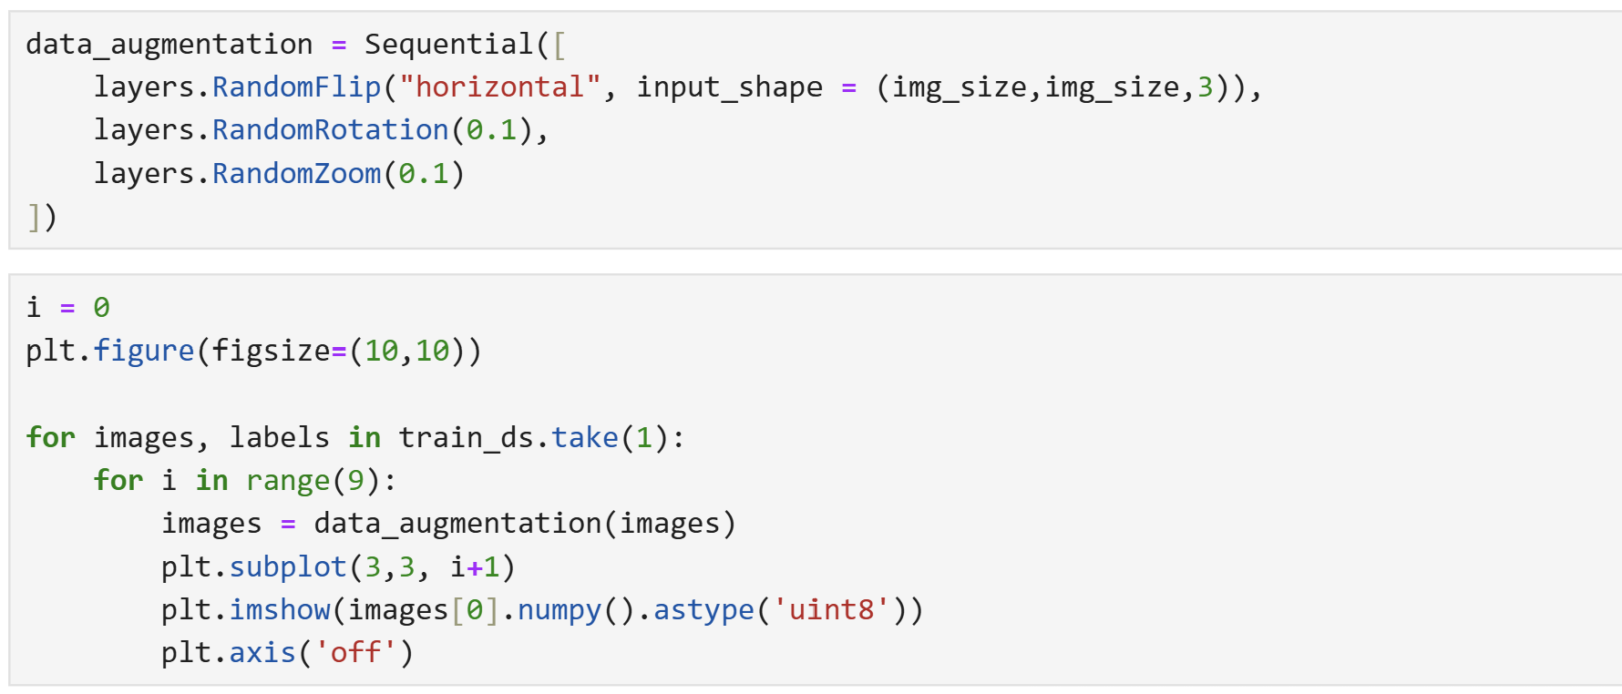

**Fig 3.3: Generating new data using Data Augmentation**

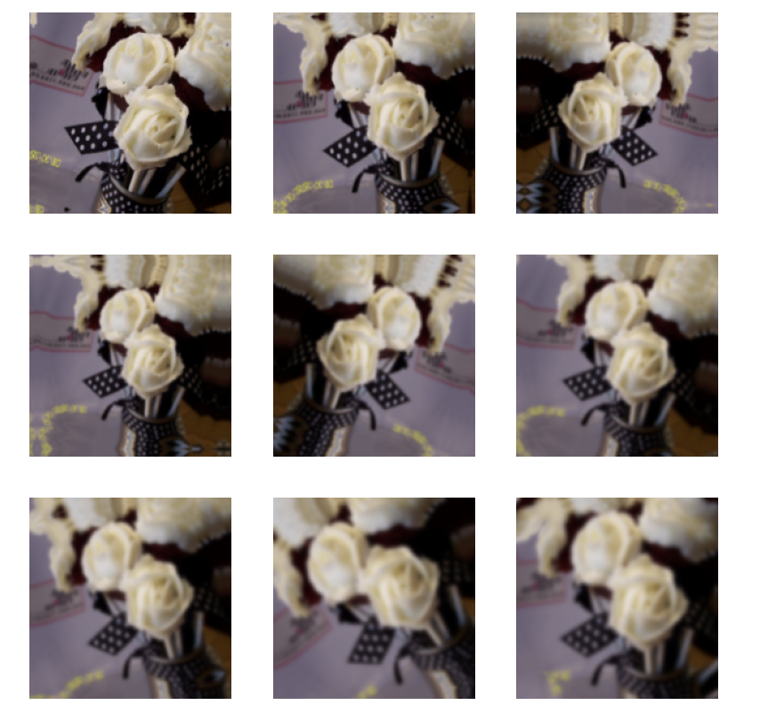

**Fig 3.4: New data generated using Data augmentation**

**5.Model building:**

In this part now we will build a convolutional network by using some important layers.

Those layers are:

• Sequential layer

• Conv2D layer

• MaxPool2D layer

• Activation layer

• Dropout, Dense and Flatten layers

These layers are used to build a CNN model. These layers are present in Keras module.

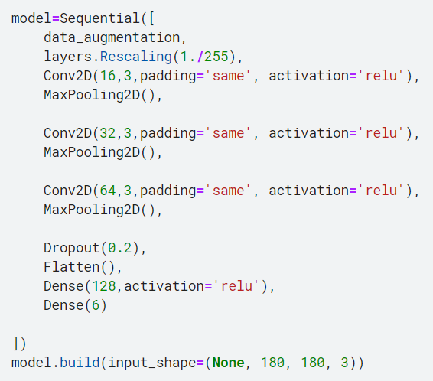

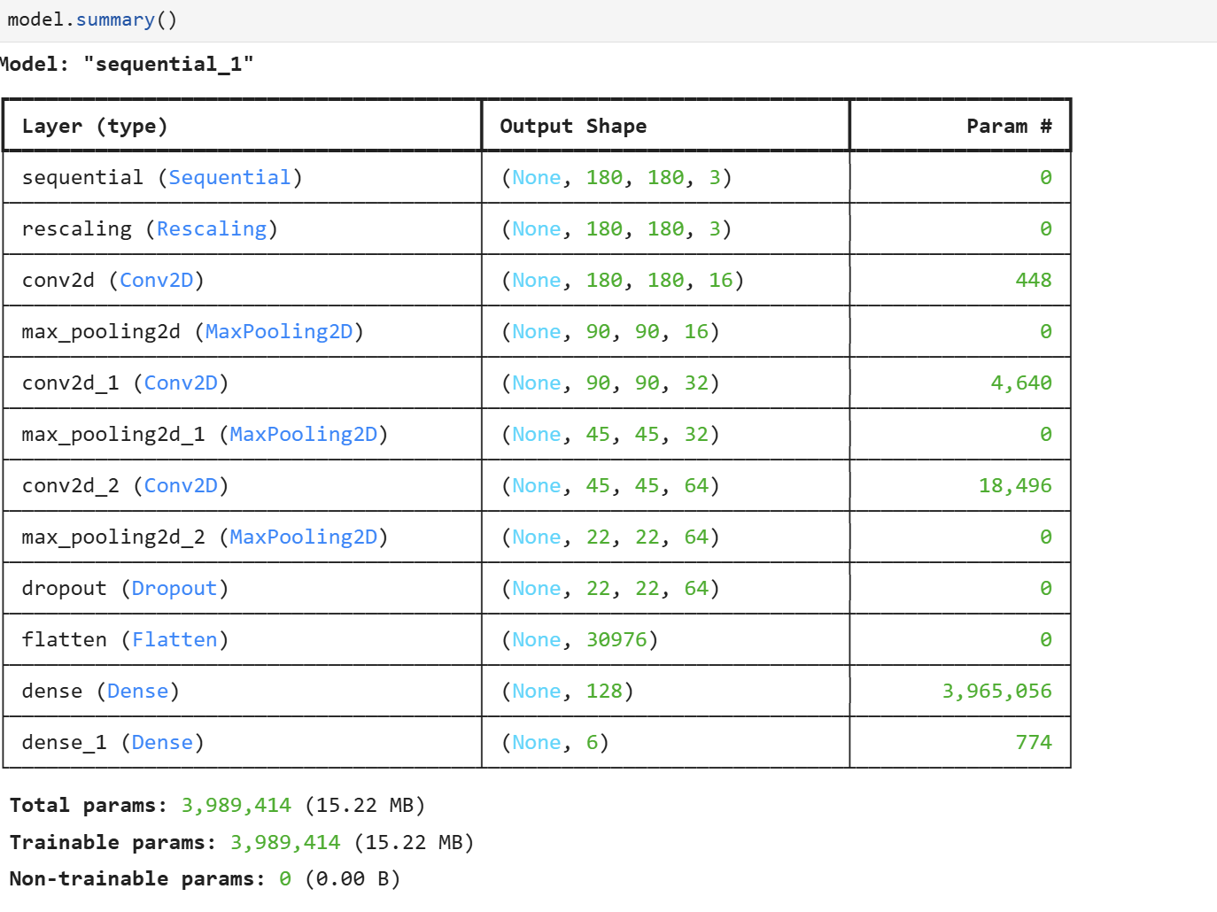

**Chapter 4**

**Result And Discussion**

**4.1. Result:**

* **Training the data**

Now let’s train the data according to their given training dataset after training the data

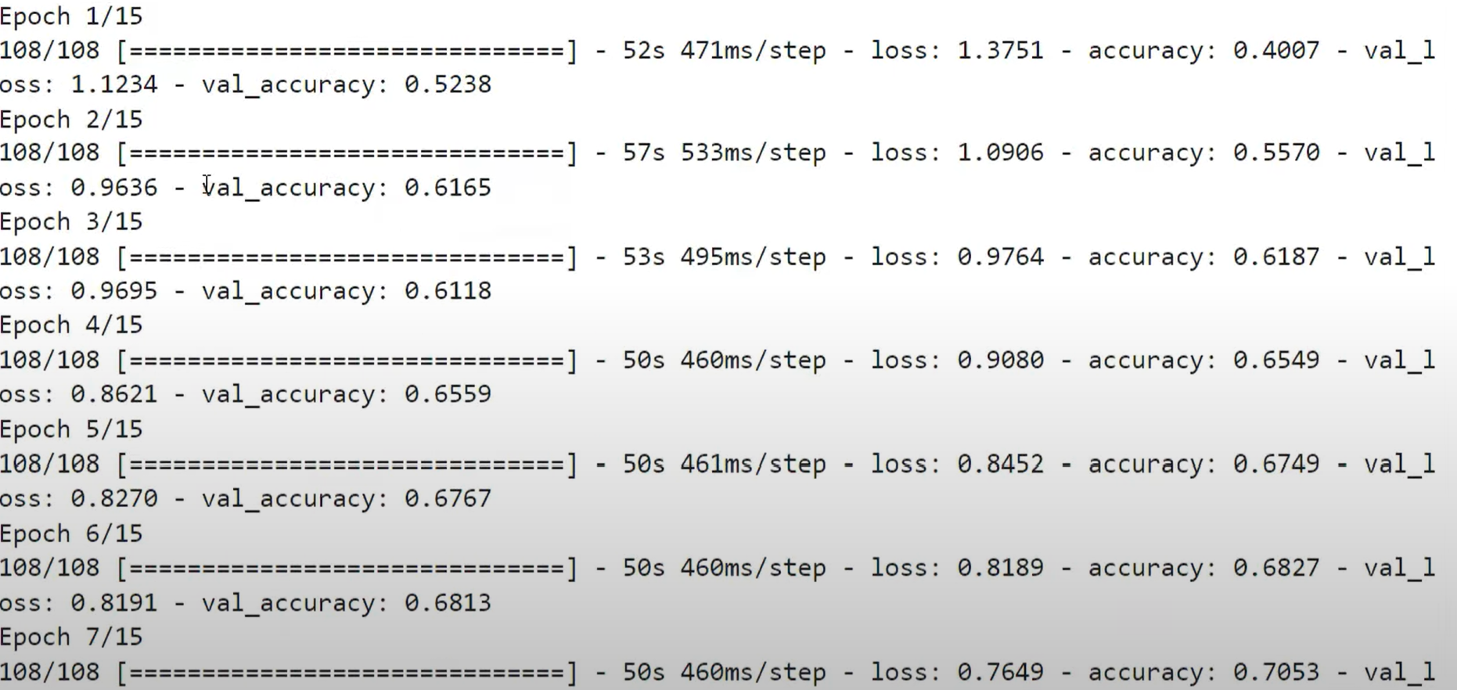

**. Training data and Accuracy** 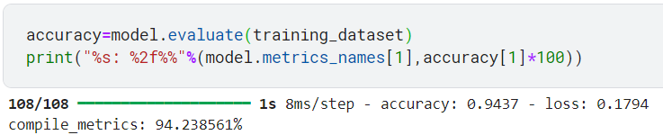

**Fig 4.2: Testing the data and Accuracy of the Model**

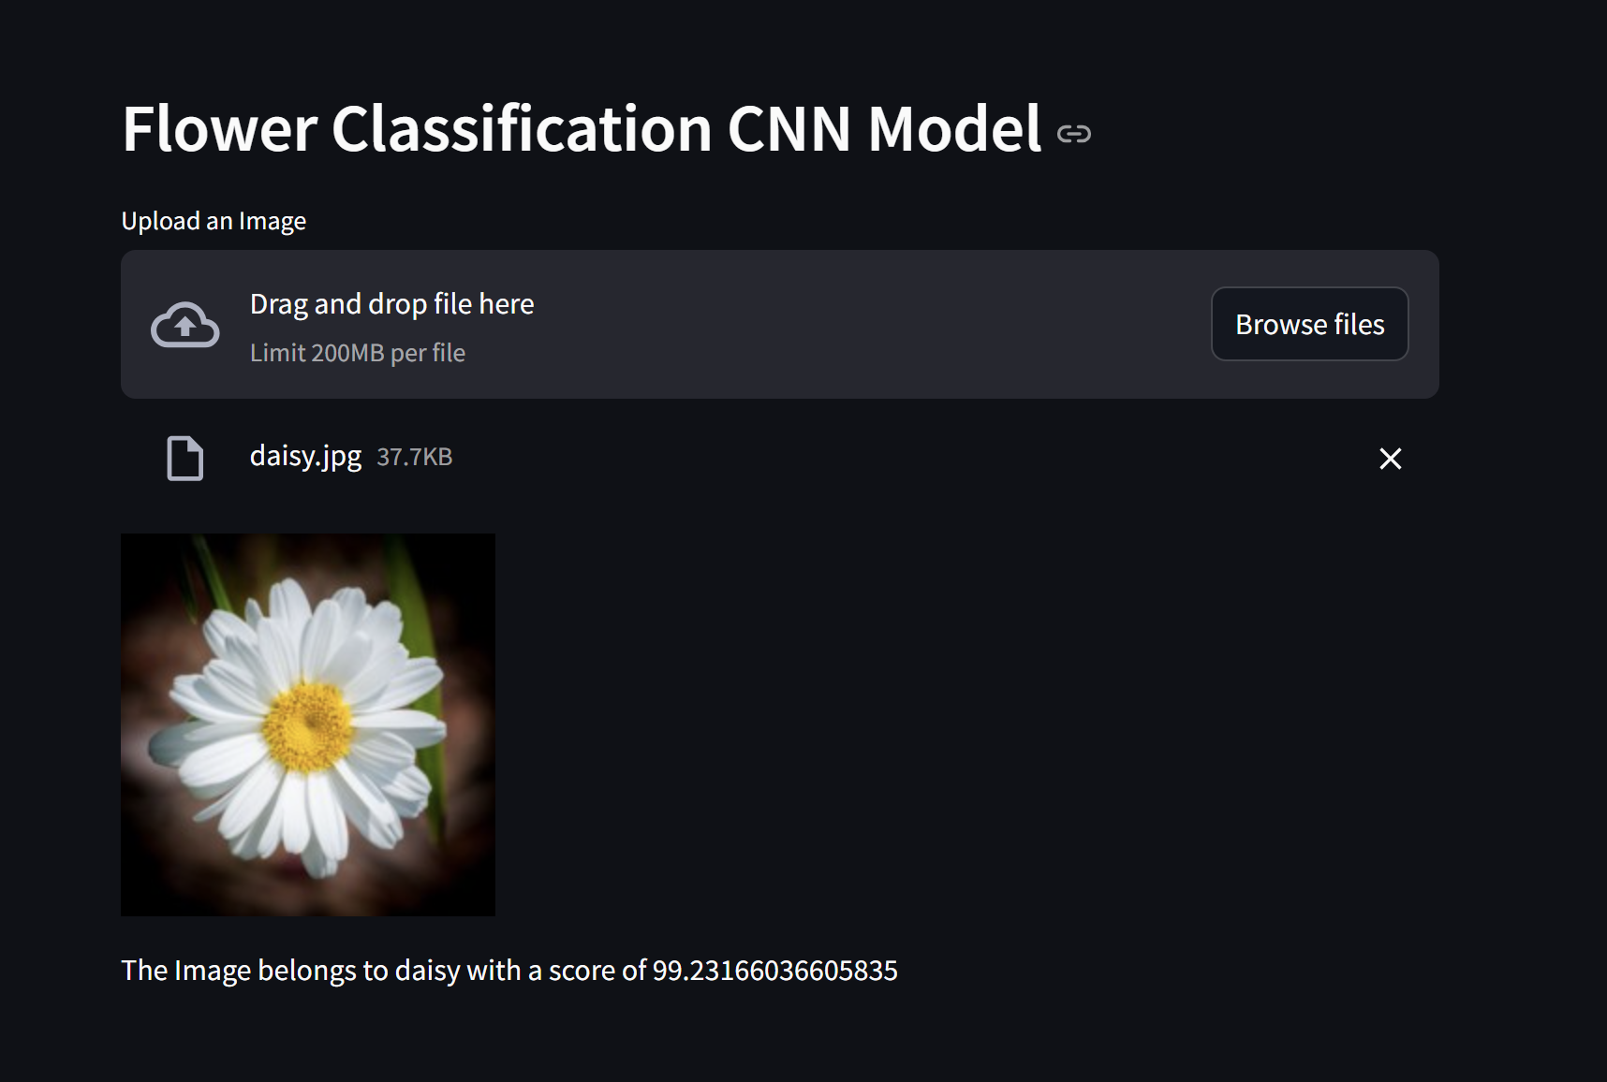

**Fig 4.3: Recognising the images of flowers (Output).**

**Discussion:**

The essential objective of this inquire about is to extend the precision of blossom acknowledgment by optimizing the convolutional neural network architecture in Keras. The most objective of this inquire about is to move forward the exactness of blossom recognizable proof by refining the convolutional neural organize design utilizing Keras. stage. Within the current setting, the optimization of the CNN design is pointed at expanding the execution of the demonstrate within the precise recognizable proof and classification of distinctive sorts of blossoms. The CNN engineering has gotten noteworthy consideration in scholarly inquire about due to its remarkable execution in efficiently solving design acknowledgment errands particularly related to picture information.

The main reason of using Convolutional neural network instead of Artificial neural network which could have also done the same thing because of the back propagation technique which it provides and gives the better result in this we don’t need to set the layer by ourself that sets the random images for filtering which reduces the maintenance cost .

This inquires about points to streamline the method of building, preparing and assessing neural organize models utilizing Keras as an interface. The application of structural optimization points to extend the execution of the demonstrate by accomplishing

more noteworthy exactness in recognizing diverse varieties in blossom shape and color. Within the setting of this ponder, it can explore the affect of different parameters, counting the number of layers, channel estimate, and pooling arrangement. Analysing diverse combinations of these models can abdicate important experiences into ideal arrangements that can move forward the model's capacity to get it the particular highlights of each blossom species. Furthermore, Keras as a system for creating profound learning models offers focal points in terms of

code clarity and user-friendliness, permitting analysts to centre on structural tests without getting as well hindered down in specialized complexities. The potential comes about of this inquire about are expected to lead to profitable

contributes to the improvement of blossom acknowledgment innovation and advances more prominent precision. These technological propels hold the guarantee of accomplishing positive results in a assortment of areas, counting botany, farming, and preservation

conservation.

**Chapter 5**

**Conclusion And Future Work**

**5.1. Conclusion:**

Blossoms are critical to individuals, but recognizing diverse sorts can be difficult. In our venture, we made a demonstrate to classify blossom pictures, and it worked superior than other models and pre-trained frameworks we tried.

With our show, anybody can take a picture of a blossom and rapidly discover out its sort. This can be moreover exceptionally supportive for scholars since it is quicker and more precise than more seasoned strategies. Us demonstrate accurately distinguished blossoms 94% of the time, appearing it works well.

Utilizing Convolutional Neural Systems (CNNs) to recognize blooms worked exceptionally well in this ponder. The CNN show accurately recognized five sorts of flowers-Daisy, Sunflower, Tulip, Dandelion, and Rose-88.88% of the time, dealing with 4317 bloom pictures with great precision.

We could have also use the ANN but due to feature learning CNN automatically learns the spatial hierarchies from the input images which first captures the primitive side that is edges and then deep dive in to further layer also or parameter sharing ,Translation Invariance ,Local Connectivity , Computational Efficiency , hierarchical Feature Extraction .

This capacity to tell diverse blossoms separated is valuable for cultivating, biological inquire about, and cultivating. The tall precision implies it can be utilized for assignments like checking wildflower populaces and making robotized plant frameworks. This consider appears that CNN models are great at recognizing complex objects like blossoms.

Blooms hold a noteworthy put in human life. Recognizing distinctive bloom sorts could be a basic however challenging assignment for numerous individuals. In our consider, we classified pictures from a blossom picture dataset utilizing our proposed demonstrate. Our show beated both comparable ponders within the writing and three pre-trained deep learning designs utilized within the consider.

With this demonstrate, indeed novices can take pictures of blossoms they are inquisitive about and rapidly learn their genus. This ponder is additionally profoundly profitable for scholars, advertising quicker and more exact comes about than conventional strategies. Our demonstrate accomplished an precision of 94%, illustrating its adequacy in bloom sort classification.

In brief, utilizing CNNs to recognize blooms gives awesome comes about and appears guarantee for progressed arrangements in cultivating, biology, and cultivate plant times.

**5.2. Future Work:**

In the future, we plan to make our model even faster and able to identify more types of flowers.

Here the future work of Flower recognition using CNN –

1. **More Flower Types:** Add more kinds of flowers for the model to recognize.

2. **Better Accuracy:** Make the model even more accurate at identifying flowers.

3.**Real-time Use:** Develop the model so it can recognize flowers instantly using a phone or camera.

4. **Adapt to Environments:** Ensure the model works well in different lighting, backgrounds, and seasons.

5.**Combine with Other Tech:** Use the model with other technologies, like augmented reality for learning or smart garden systems.

6.**Easy-to-Use Apps:** Create simple apps for people to use, including botanists and gardeners.

7. **Bigger Dataset:** Gather more varied flower images to improve the model.

8. This model can be replicated for flower recognition in other areas especially in the area where is the biggest and richest flora ecosystem in the world.

Explore using the model for related tasks like detecting plant diseases and monitoring crops.

References

[1] Flower Recognition using Deep Convolutional Neural Networks by, Ariff Md Ab Malik, Mohd Razif Shamsuddin, Mohd Azraei Adnan

[2] An efficient classification of flower images with convolutional neural networks by A Hari Chandana, Ch Raghava Prasad, P Sasi Kiran, B Jwalalakshmamma, K Komali, M V.N Manoja, Syed Inthiyaz

[3] “Classification of flower species using CNN models” by Ahmet Cinar, Emine cengil.

[4] Convolutional Neural Networks (CNN) Using Deep Learning for Computer Vision Applications by Varadi Rajesh, Umesh Parameshwar Naik, Mohana Mohana